LAB 9

**Lab Task 9.1) Write a program that prints the area and the parameter of the rectangle**

#include <iostream>

using namespace std;

int main()

{

int a,b,c,d;

cout << "Enter Hight of Rectangle " << endl;

cin >> a;

cout << "Enter width of Rectangle " << endl;

cin >> b;

c=a*b;

cout << "Area of Rectangle is "<<c<< endl;

d=2*(a+b);

cout << "Parameter of Rectangle is "<<d<< endl;

return 0;

}

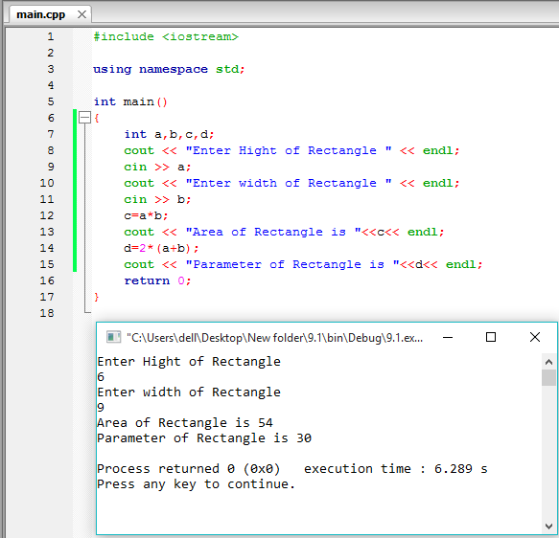

**Lab Task 9.2) Write a program that checks whether the entered alphabet is a vowel or** **not.**

#include <iostream>

using namespace std;

int main()

{

char c;

int islowercaseVowel, isUppercaseVowel;

cout<<"Enter an alphabet: ";

cin>> c;

islowercaseVowel = (c == 'a' || c == 'e' || c == 'i' || c == 'o' || c == 'u');

isUppercaseVowel = (c == 'A' || c == 'E' || c == 'I' || c == 'O' || c == 'U');

if (islowercaseVowel || isUppercaseVowel)

cout << c << " is a Vowel.";

else

cout << c << " is not a Vowel.";

return 0;

}

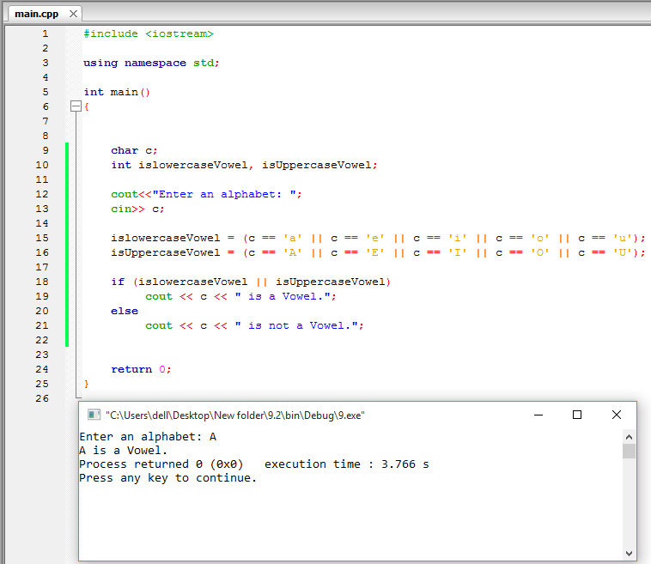

**Lab Task 9.3) Write a program that checks whether the number entered as input is odd or even.**

#include <iostream>

using namespace std;

int main()

{

int a;

cout << "Enter a number " << endl;

cin >> a;

if ((a%2==0))

cout <<a<< " is an even number.";

else

cout << a << " is an odd number.";

return 0;

}

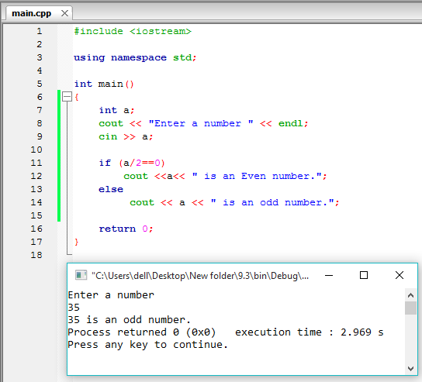

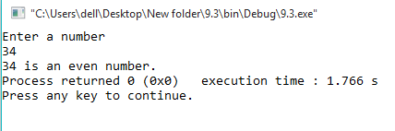

**Lab Task 9.4) Write a program that takes two numbers as input and then calculate and print the sum, difference, product and quotients of these two numbers**

#include <iostream>

using namespace std;

int main()

{

float a,b,c,d,e,f,g,h;

cout << "Enter First number " << endl;

cin >> a;

cout << "Enter second number " << endl;

cin >> b;

d=a+b;

cout << "Sum: "<< d << endl;

f=a-b;

cout << "Difference: "<< f << endl;

g=a*b;

cout << "Product: "<< g << endl;

h=a/b;

cout << "Quotient: "<< h << endl;

return 0;

}

